Leifeld Metal Spinning: a successful interim report
Overcoming challenges in difficult times
Leifeld Metal Spinning GmbH looks back at a successful first half of the year- although the period was and is characterized by the Corona pandemic. In order to stay one step ahead, the Mechanical Engineering is constantly working on new technologies, processes and products. Leifeld is finally able to present innovations live at trade fairs again. The company reported an incoming order volume of almost EUR 20 million in the first half of the year.

The economic challenges resulting from the ongoing Corona pandemic, the war in Ukraine and a disrupted supply chain continue to persist. “We are still experiencing serious supply bottlenecks, such as with electronic components in switch cabinets”, explains Oliver Reimann, CEO of Leifeld Metal Spinning GmbH. “However, we benefit from our financially strong parent company Nihon Spindle (Sumitomo Heavy Industries). Despite all odds, we were able to meet long delivery deadlines to our end customers in a disrupted supply chain environment thanks to a not insignificant “Cash” deployment and opting for an anticipatory purchasing strategy”. Using an interdisciplinary planning and an intelligent sourcing strategy, Leifeld has been able to generate significant competitive advantages, generate new orders and further expand its position as global market leader.

“With our constantly growing Research and Development Department we work continuously on new technologies, processes and products”, says Oliver Reimann. A main area of focus in the last months has been the patent registration for the process optimization 4.0 which aims for zero error in the process. The new solution is already tried and tested in practice and e.g. is successfully in use for LEIFELD AFPM, the flow-forming machine for poles and pipes. Another area of focus was the product launch of the likewise patent protected Wheel Spinning Centers- LEIFELD WSC Flex for the manufacture of aluminum wheels. With the new process the user has great flexibility and can produce various rim diameters, profiles, wall thicknesses, and rim widths without having to use expensive tools. “We have also focused heavily on technologies and processes using which weight-optimized rotor shafts can be manufactured for electro-mobility”, reports Reimann.

Innovations that were largely crippled in the last two years due to the Corona pandemic can finally be presented in trade fairs and around the world again. Leifeld presented its product innovations at the SpaceTech Expo in the USA, the IMTEX Forming in India and the Automotive Engineering Expo in Japan, among others. Customer appointments were also possible only to a limited extent in the past year. This has improved significantly once again. “Nothing takes the place of personal contact” Leifeld CEO is pleased to point out.

Picture:
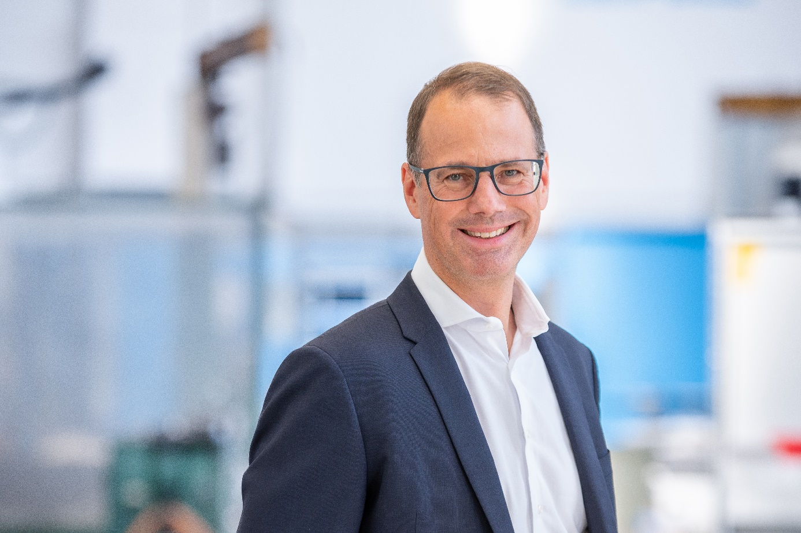
Oliver Reimann, CEO at Leifeld Metal Spinning: "We are continuously working on new technologies, processes and products."

About Leifeld Metal Spinning:
Leifeld Metal Spinning GmbH develops, manufactures, and distributes machine tools for chipless metal forming. More than 200 employees work at locations in Germany, the USA, Japan and China. The company is member of the Global Metal Forming Group and is present worldwide with numerous representatives in all major markets. The core industries are automotive, aerospace, energy, and industrial applications. The production site and headquarters are located in Ahlen, Germany.
The product range includes machine tools for the manufacture of various intermediate or end products. The machines are equipped with multifaceted automation solutions and can be individually adapted to suit the customer's requirements. In 130 years of business, Leifeld Metal Spinning has manufactured over 6,150 machines and delivered them to 60 countries.
Leifeld Metal Spinning also supports its customers with a comprehensive range of services which cover the entire product lifecycle. The company offers all the services - ranging from research & development, technical service, spare parts procurement, consulting, and training to the retrofitting of second-hand machines. Leifeld develops new processes, technologies, and products, and has filed for patents on more than 140 inventions to date.

For more information, please visit: www.leifeldms.com

Press contact at Leifeld Metal Spinning:
Mrs. Beate Hiltrop, Head of Marketing
+ 49 (0) 2382 96607 309
press-office@leifeldms.com
www.leifeldms.com

