Leifeld Metal Spinning takes over Boese Systems GmbH & Co. KG:
The company’s service business continues expansion with acquisition.

Leifeld Metal Spinning has completed a full acquisition of Boese Systems GmbH & Co. KG. This move allows the metal forming machine tool specialist to extend its expertise in areas such as the retrofit of PNC spinning machines. With this acquisition, Leifeld is one step closer to achieving its goal of offering customers complete comprehensive service.

Leifeld's machines for chipless metal forming are used worldwide in the automotive, aerospace, wind power and energy industries. As part of an asset deal, the company from Ahlen in Germany has now taken over Boese Systems, a supplier of PLC programming, drive technology and NC-controlled axes. With this acquisition, Leifeld benefits from the long-standing expertise and competence of Boese in the service and modernization of PNC spinning machines as well as control systems and their upgrades. "In addition to staff reinforcement in our service team, we are acquiring valuable expertise in the expansion of our services with the purchase of Boese Systems. Especially for older spinning machines with PNC controls, we now have a clear added value in customer support," says Oliver Reimann, CEO of Leifeld. "With this, we’re reinforcing our service strategy that highlights customers as our focus.”

Before the former managing director Kevin Boese started his own family business, he worked for the Ahlen-based machine builder for almost eleven years. As a supporter of the new service orientation at Leifeld, Kevin will now add his talents and expertise to this division of the company as a technician. He will play a leading role in implementing and further developing the new strategy. Boese brings with him extensive expertise in control systems from the manufacturer Pauly. These are mainly installed in the older PNC machines.

"With my company, I have been a driving force in developing the controls together with Pauly over the past few years," Boese reports. "Now, in order to retrofit older machines, we at Leifeld will optimise the programme storage as well as the online access." The machine builder also benefits from his experience in being able to convert and expand the systems as easily as possible. Added to this is his expertise in electrical design to simplify commissioning.

New Orientation with Customer Focus

Leifeld offers a worldwide range of services. This enables customers to reduce their operating costs, maintain the availability of the machines and increase their safety throughout the entire machine life cycle. The offer includes inspections, maintenance contracts, repairs, spare parts supply, modernisations, trainings as well as the purchase and sale of used machines.

Leifeld service manager Stephan Stamm: "With the new orientation we want to intensify customer proximity. Four service technicians are now a permanent part of our field service team. On the so-called road show, they visit and advise our customers on site."

With the newly gained expertise, Leifeld can tackle the retrofit and used machine business more intensively. "After the general overhaul of the machines at our company with original parts or, if necessary, new designs, they are again in as-new condition," promises Stephan Stamm. "Our customers define with us the scope of services that makes the most sense for them. We provide comprehensive services, just as we do for new machines - from commissioning to component development. The availability of spare parts, especially in the area of the control system, is again guaranteed." When selling a used Leifeld machine, the service team is the right contact for all questions. In addition, the spare parts market is expanded: Leifeld increases its minimum stock of selected components to improve the availability of spare parts.

3.870 charcaters incl. blanks

Pictures:
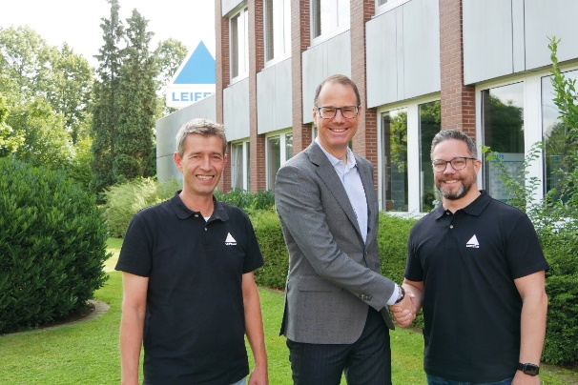
Picture 1: Leifeld continues to expand its service business: (from left) Service Manager Stephan Stamm, Managing Director Oliver Reimann and new service team member Kevin Boese.

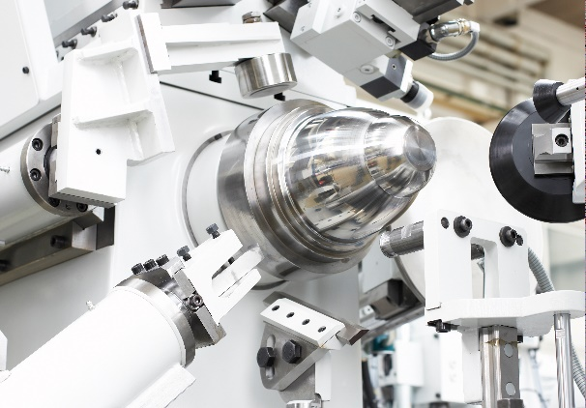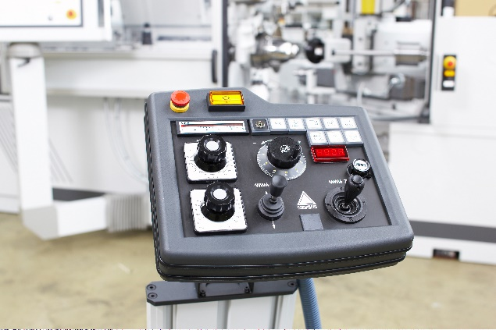
Bild 2 und 3: After the general overhaul of the PNC spinning machine from Leifeld, the machine for forming high-gloss aluminium reflectors is in mint condition.

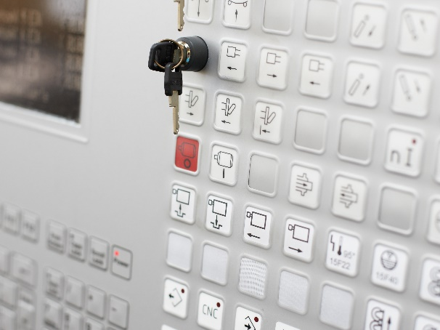
Bild 4: The Leifeld team optimises programme storage as well as online access for older PNC machines with Pauly control.

You can download the high-resolution images here.

About Leifeld Metal Spinning:
Leifeld Metal Spinning GmbH develops, manufactures, and distributes machine tools for chipless metal forming. More than 200 employees work at locations in Germany, the USA, Japan and China. The company is member of the Global Metal Forming Group and is present worldwide with numerous representatives in all major markets. The core industries are automotive, aerospace, energy, and industrial applications. The production site and headquarters are located in Ahlen, Germany.
The product range includes machine tools for the manufacture of various intermediate or end products. The machines are equipped with multifaceted automation solutions and can be individually adapted to suit the customer's requirements. In 130 years of business, Leifeld Metal Spinning has manufactured over 6,150 machines and delivered them to 60 countries.
Leifeld Metal Spinning also supports its customers with a comprehensive range of services which cover the entire product lifecycle. The company offers all the services - ranging from research & development, technical service, spare parts procurement, consulting, and training to the retrofitting of second-hand machines. Leifeld develops new processes, technologies, and products, and has filed for patents on more than 140 inventions to date.

For more information, please visit: www.leifeldms.com

Press contact at Leifeld Metal Spinning:
Mrs. Beate Hiltrop, Head of Marketing
+ 49 (0) 2382 96607 309
press-office@leifeldms.com
www.leifeldms.com

Leifeld Metal Spinning GmbH, Feldstr. 2-20, 59229 Ahlen

